
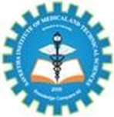
SIMATS ENGINEERING
Saveetha Institute of Medical and Technical Sciences
Chennai-602105

Name: A.Siva suraj sai
Reg.no:192425276
Course Code: MLA0407
Course Name: Deep Learning
Date:04/08/2026

The image shows the results page of an online MCQ Test – CO2 AT1, where I achieved an impressive 47 out of 50 total points, reflecting a strong understanding of the subject. It also displays the registered email address used for the assessment. The overall experience appears to be smooth and user-friendly, with a clean interface that makes it easy to view the score and submitted details. Successfully scoring 49/50 provided a satisfying and motivating experience, boosting confidence and encouraging continued learning and academic improvement.

